**ព្រះរាជាណាចក្រកម្ពុជា**

**ជាតិ សាសនា ព្រះមហាក្សត្រ**

**វិទ្យាស្ថានបច្ចេកទេសកម្ពុជា**

**Institut De Technologie Du Cambodge**



កិច្ចការស្រាវជ្រាវ៖ ប្រព័ន្ធគ្រប់គ្រងផ្សារទំនើប

ដឹកនាំដោយសាស្រ្តាចារ្យ៖ ចាន់ សុផល

មុខវិជ្ចា៖ Data Structure and Programming 1

រៀបរៀងដោយនិស្សិតឆ្នាំទី២នៃដេប៉ាតឺមង់ AMS-1

Group name: ***Work Hard Team I2 AMS-1***

Project Name: ***Supermarket Management System***

Group Leader: Chou Vandy **ID: e20200664**

Team Member: Kry Senghort **ID: e20200706**

Chum Piseth **ID: e20200863**

Keo Vonmonyroth **ID: e20200759**

Chorn Chanlakhena **ID: e20201209**

For this project, our team have decided to write a program about Supermarket Management System. To make it detailly, we are going to show you as below processes.

1. **What made us choose this?**

As the population increases, marketing has become an even bigger problem. All the experts of marketing have developed obviously in each session. This Supermarket Management System can either reduce the amount of people or wasted money for people’s working, make it easy to arrange the marketing system. Particularly, it repeats as the modern tense 4.0 of industry. In cooperation of a supermarket, all the goods are kept differently and divided partially. to make it easily without direct purchase, the consumers can purchase through online shop or ordering. This project shows you how to store goods or keep it. Furthermore, it also shows you how to calculate and sum up all the price of the goods that consumers order. After all the sold goods are purchased, it also stores data in each month to show about credit and profit. In this project, the employee management is also demonstrated with their workday.

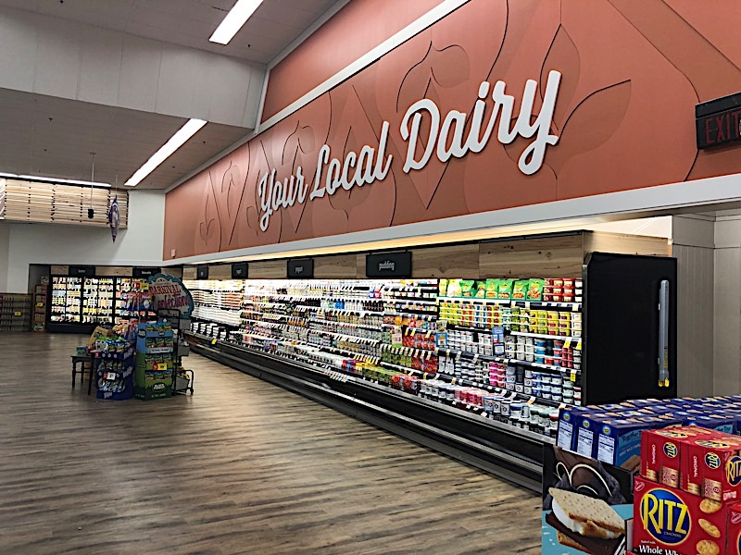

1. **What is the process?**

* Enter your good to see:
* Choose type of good:

Show type of good to chooser:

Input the user for their goods:

Input their quantity of goods:

Total their balance:

1. **Resources**

**IDE: code::blocks and Clion**

**C programming language:** switch case, variable, arrays.

1. **Time of making**

Started December,2021, expected to be ready for next month.

1. **Conclusion**

A program to allow consumer for their purchasing the goods and return them the total of price of their goods.